UE Throughput Aware IFLB (TPIFLB) – additional TA issues

Contents

1 UE selection 2

1.1 Problem 2

1.2 Proposed solution 2

1.3 Conclusion 3

2 Definition of TP "mapping function" 3

2.1 Problem 3

2.2 Solution alternatives 3

2.3 Proposed solution 3

2.4 Self-tuning of the proposed solution 7

2.5 Conclusion 9

3 TP ranking method 9

3.1 Problem 9

3.2 Proposed solution 10

3.3 Conclusion 11

4 Fallback alternative: RSRP based ranking 12

5 Parameterization and observability 12

5.1 Configuration 12

5.2 Observability 13

6 Verification and risk 13

7 References 13

# UE selection

## Problem

Due to intentional rejection of UE with less favorable throughput (TP) relation between the target and source cell, a higher number of UE need to be selected for IEF measurements, in order to meet the IFLB targets. The calculation of the *lbFreqMeasAmount* needs to be modified.

***Assumption***: CALM a pre-requisite for TPIFLB. – Hence, alignment with legacy IFLB is not necessary; updating the *lbFreqMeasAmount* calculation for CALM is sufficient.

The BNR feature should not be affected. It uses the ratio of qualified measurement reports versus the number of IEF measurements started on the target frequency as a measure of the "hit rate" of the various neighbor cells on the target frequency. The hit rate estimation shall not be affected.

## Proposed solution

One purpose with CALM is to optimize the use of IEF measurements for load balancing purposes. There is a scaling limit for the *lbFreqMeasAmount* value, restricting the number of IEF measurements in relation to the estimated total *lbAmount* on a target frequency. The following calculation is used:

|  |
| --- |
| $${lbFreqMeasAmount}_{f}=\frac{lbMeasScalingLimit*\sum_{Freq}{{lbAmount}_{t}}}{\left(lbMeasScalingLimit-1\right)*{totalHitRate}_{f}+1}$$ |

The *lbMeasScalingLimit* parameter is used to limit the measurement scaling. In addition, there is a discount of the *lbAmount* values for cells with poor hit rate (not shown here), in order to avoid an acceleration of the IEF measurements in scenarios with severe UE depletion, where the hit rate for the affected load balancing relations may drop to very low levels.

The TPIFLB feature introduces reject of qualified IEF measurements. If the *reject ratio* is the same for all target cells (on the same target frequency), this could quite easily be compensated by multiplying the ${totalHitRate}_{f}$ value in the calculation above with the expected reject ratio (a fractional value in the range: 0..1). In particular, if the reject ratio is controlled with a configuration parameter, the modification is straightforward. The solution respects the *lbMeasScalingLimit* parameter, which is an advantage (offering a possibility for the operator to control the additional measurements; requirement according to the updated MR in September).

If it is expected that the reject ratio may differ between the target cells, it might require being monitored and the estimated reject ratio be used specifically for each cell. In this case, the ${totalHitRate}_{f}$ value in the calculation may have to be replaced with an addition of the hit rate multiplied by the estimated reject ratio for each target cell:

|  |
| --- |
| $${lbFreqMeasAmount}_{f}=\frac{lbMeasScalingLimit*\sum_{Freq}{{lbAmount}_{t}}}{\left(lbMeasScalingLimit-1\right)*\left(\sum_{Freq}{{bnrHitRate}_{t}*{(1-rejectRatio}_{t})}\right)+1}$$ |

Further details may be decided in the pre-study phase.

The proposed change does not affect the calculation of the *lbAmount* values, only the calculation of the *lbFreqMeasAmount* value for each target frequency.

## Conclusion

The proposed solution is simple and straightforward.

# Definition of TP "mapping function"

## Problem

The TPIFLB feature require awareness of the achievable UE throughput in both the intended source and target cells before a particular UE can be selected for load balancing action (an IEF HO). Although a TP assessment would be possible in the serving (source) cell (based on the UE CQI reporting and the "Jianning formula"; MR1260), a corresponding TP assessment in the target cell is not possible before the UE selection is performed. Besides, the required mechanisms for that have been removed from L15B, due to scope reduction.

The TPIFLB (L15B) feature has to rely on the measurement quantities (RSRP and RSRQ) received from the UE in the IEF measurement report triggering the final UE selection and load balancing action. The measurement report includes RSRP and RSRQ for both the source and the target cell.

The task is to propose a method for reasonable TP prediction in both the source and target cells based on the information available in the measurement report received from the UE. Self-tuning mechanisms for the calibration of the TP prediction should be included as part of the solution.

## Solution alternatives

When the TA study started, two principally different alternative solutions were suggested:

1. A TP "mapping *table*", based on feedback from TP assessments performed in the target cell after a completed IEF HO, wherein a matching of the measurement quantities received from the UE with the stored entries in the mapping table would be used to predict the TP in the target cell based on the previous experience.
2. A TP "mapping *function*", where the TP prediction is performed with a calculation based on the measurement quantities received from the UE; feedback from actual TP assessments in the target cell were assumed for the purpose of self-tuning the mapping function.

Neither of those alternatives is still possible, due to L15B scope reduction, where the TP assessment based on CQI reporting is removed; also the support for feedback from the target cell is removed.

The remaining alternative is to perform the TP assessment as a calculation based on the measurement quantities received from the UE, but without the previously expected feedback from the target cell. The need for self-tuning remains, but restricted to the information available in the source cell, without feedback from the target cell.

The traffic load information (subscription ratio) is available from both the source and target cells and can be used for the TP assessment.

## Proposed solution

It is proposed that the TP prediction is based on a formula consisting of three main components:

1. The *Cell Peak Throughput* (CPT) value; this is a value depending on the available number of physical resource blocks (PRB) and the (theoretical) peak number of bits transferred per PRB (with MIMO rank = 1).

The value might be possible to calculate based on the physical cell configuration. However, it is considered the CPT parameter should be operator configurable, possibly with a default value based on the configured RF bandwidth. Expected CPT values are approximately 40 – 45 Mbps per 10 MHz RF bandwidth, including some reduction required to compensate for "implementation loss".

1. The *cell load factor*; this is a value depending on the cell load in terms of *subscription ratio* (*sRatio*) and the CPT:

$$cellLoadFactor=\frac{1}{1+sRatio*{CPT}/{C_{1}}}$$

The CPT value in the denominator is needed to take into account that the *sRatio* is normalized with respect to the cell capacity and not an absolute load measure.

The quotient ${CPT}/{C_{1}}$ controls the TP roll-off rate as a function of the *sRatio*.

The $C_{1}$ parameter needs to be configurable (MOM attribute). The value may depend on the configuration of the *QCI subscription quanta* and *cell subscription capacity* parameters applied in the cell. A guideline for the configuration of the $C_{1}$ parameter is required. It may **require elaboration based on simulation** to find out a suitable guideline. Expected values are in the range of 5 to 20 Mbps, but this needs to be confirmed with simulations.

***Note***: The assumption here is that the *sRatio* is suitable as a traffic load value for this purpose. However, the *sRatio* is a quantity used primarily to guide the IFLB load balancing algorithm. Later evaluation may show that manipulation of the *sRatio* is required in order to guide IFLB towards optimum TP performance. It would impact the cell load factor; alternative means might be required for that reason.

1. The *path loss factor*; this is a value depending on the path loss and, as a result of that, the SINR the UE experiences in the cell:

$$pathLossFactor=\frac{S_{UE}}{1+S_{UE}}\text{; }S_{UE}=2^{\left(RSRP-C_{2}\right)*{\log_{2}(10)}/{10}}$$

The $S_{UE}$ value is a linear representation of the SINR with some offset, determined by the $C_{2}$ parameter. The $C_{2}$ parameter represents the interference and noise (IN) the UE experiences in the cell, with an additional offset required to fit the TP prediction to the actual path loss impact on the TP.

The $C_{2}$ parameter is expected being both time and location variant. Self-tuning is required to handle time fluctuations. The tuning needs be performed specifically for each LB relation, and separately for the source and target cell, in order to reduce the fluctuations depending on the UE location, but it is not considered feasible to increase the granularity beyond that.

As a result, the self-tuning process is expected to present an "average" $C_{2}$ values, respectively for the source and target cell, to be applied for any UE evaluated regarding the specific LB relation; more about tuning the "average" $C_{2}$ value later on in section 2.4.

It is evident that each UE is, in practice, going to experience a deviation between the $C_{2}$ value and the actual IN level it experiences in the cell.

Putting it altogether, the three components results in the following formula for the TP assessment:

$$ueThroughput≅\frac{CPT*S_{UE}}{\left(1+sRatio*{CPT}/{C_{1}}\right)*\left(1+S_{UE}\right)}\text{; }S_{UE}=2^{\left(RSRP-C_{2}\right)*\log_{2}(10)/10}$$

The *CPT* and the $C_{1}$ parameters are expected being operator controlled parameters (MOM attributes) to be defined in the pre-study.

The *sRatio* is a quantity depending on the configuration of the *qciSubscriptionQuanta* and the *cellSubscriptionCapacity* parameters in the cell (eNB). Hence, the $C_{1}$ parameter depends on those configurations; a guideline for the operator is required.

The $C_{2}$ parameter requires self-tuning in the eNB. A method for the self-tuning is outlined in section 2.4. The tuning mechanism may require configuration in itself.

The expected UE throughput prediction (*ueThpt*) as a function of the RSRP (based on the formula) is illustrated in Figure 2.3‑1 below.

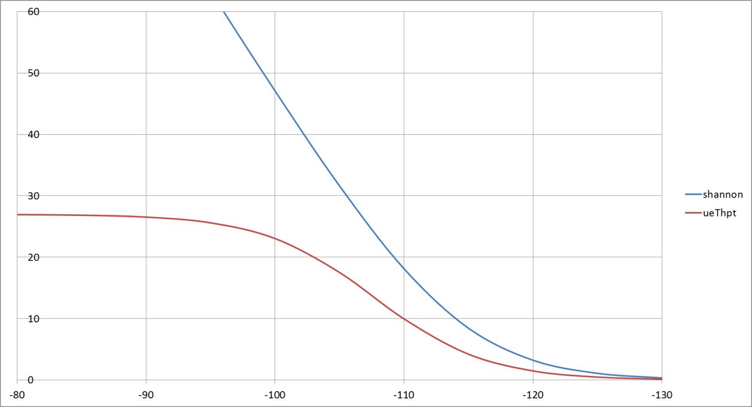

**Figure 2.3‑1: UE throughput prediction and the Shannon curve as function of RSRP**

The example is a "moderately loaded" 10 MHz cell (*CPT* = 43.0 Mbps; *sRatio* = 0.20) with an assumed IN level at −114 dBm. The $C_{1}$ value is 14.5 Mbps. The $C_{2}$ value is −107.67 dBm; i.e., offset 6.33 dB relative the IN level.

The blue curve is the throughput according to the Shannon theorem for reference. The CPT and the traffic load level restricts the UE throughput at high RSRP levels; note that MIMO is so far not taken into account in this model (MIMO rank = 1 is assumed).

The *path loss factor* curve shows good consistency with an example of drive-test data collected in Japan 2012, see Figure 2.3‑2 below. Many details about the drive-test are unknown, but it is assumed it is a 5 MHz LTE cell (re-farming of WCDMA spectrum). The *CPT* value is set to 21.0 Mbps. The $C_{2}$ value = −95 dBm (including an offset to the IN) has been used to fit the TP assessment curve to the drive-test data. (MIMO is not taken into account.)

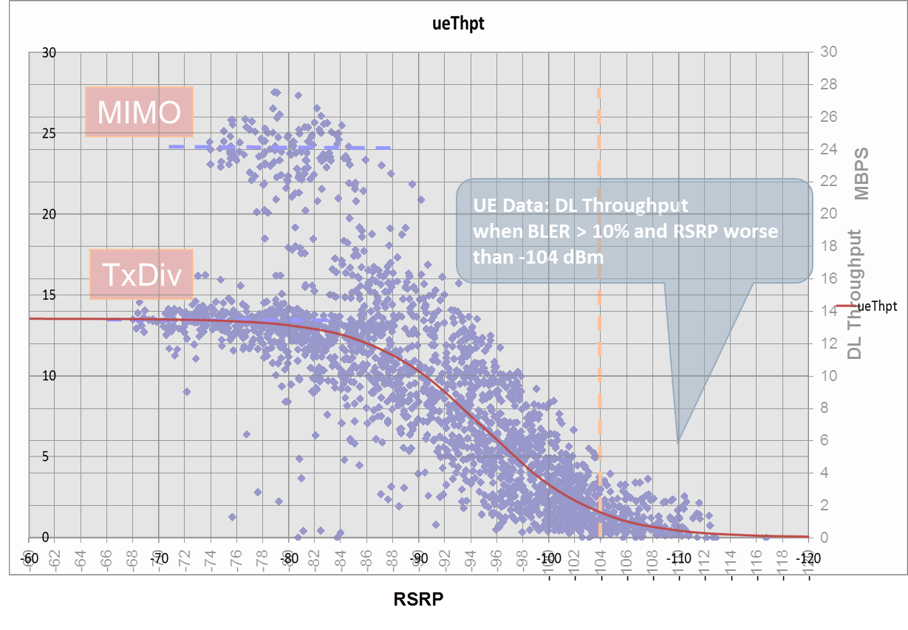

**Figure 2.3‑2: Example of *path loss factor* versus drive-test data**

Also the *cell load factor* curve shows good consistency with respect to the traffic load in field data collected from cells around the Yamanote train line in Tokyo, Japan, October 2014. The Figure 2.3‑3 below shows the average UE throughput KPI versus the number of connected UE in a large number of cells. The consistency with the overlaid *cell load factor* curve is quite acceptable, given appropriate fitting of the CPT and $C_{1}$ parameters.

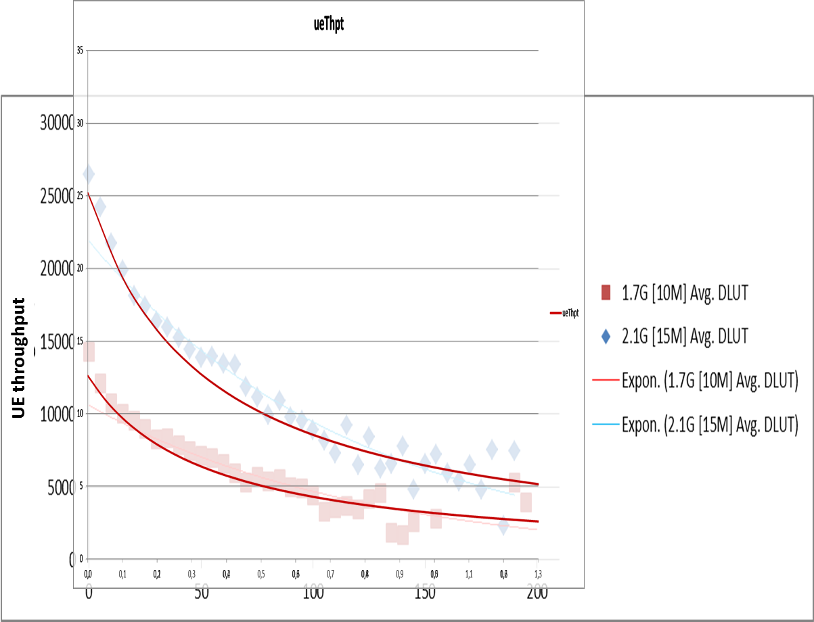

**Figure 2.3‑3: Example of cell load factor versus UE throughput KPI data**

It is assumed that the *cell load factor* and the *path loss factor* can be treated independently and simply be multiplied to make a TP assessment. This is not necessarily the entire truth; it may depend on the scheduler realization in the eNB, amongst other possible influences. Nevertheless, considering the other uncertainties in assessment of these two factors, the assumption seems reasonable for the present purpose. Other uncertainties are likely much more compromising.

## Self-tuning of the proposed solution

The $C_{2}$ parameter is most critical for an accurate TP assessment using the method in the previous section. The parameter is used to represent the IN term in the SINR (or more precisely, the IN term with certain offset) based on the RSRP value received from the UE in the measurement report (values in decibel):

$$SINR=RSRP-IN=RSRP-C_{2}+"offset"$$

The actual SINR for a particular UE is not available in L15B. Therefore, self-tuning is required to set the $C_{2}$ parameter value for the TP assessment. It is not seen as feasible to do a UE specific tuning of the value, but an "average" value for UE appearing within the intersection between a source and a target cell is considered possible.

The proposed method to apply utilizes the presence of joint RSRP and RSRQ observations in the measurement reports received from UE within the source to target cell intersection the LB relation defines. The RSRQ expresses the relation between the RSRP and the RSSI (according to the definition in [3]; with values in linear representation in Watt):

$$RSRQ=\frac{N*RSRP}{RSSI}$$

The value *N* is the number of E‑UTRAN resource blocks (RB) within the RSSI measurement bandwidth. The RSSI (in Watt) is a compound of (*a*) the total received power of the scheduled DL transmissions from the measurement object (cell) in the measurement bandwidth and (*b*) the total received power from all other sources.

The RSSI does not distinguish the different sources. Nonetheless, when the received power from the measurement object is low enough (large negative RSRQ in dB); the received power from all other sources, i.e., interference and noise, is dominating the RSSI. Hence, at low enough RSRQ, it is possible to neglect the scheduled power from the measurement object and approximate the IN term based on the RSRP and RSRQ measurement quantities received from the UE (values in Watt):

$$IN≅RSSI=\frac{N*RSRP}{RSRQ}$$

Or, alternatively, with values expressed in decibel:

$$IN≅RSRP-RSRQ+\log_{10}\left(N\right)*10$$

Consequently, it is possible to make an assessment of the $C_{2}$ parameter based on the RSRP and RSRQ measurement quantities:

$$C_{2}≅RSRP-RSRQ+"system offset"$$

The "system offset" in the expression the factor N (in dB) and the fact that the $C_{2}$ parameter is not identical with the IN; there is an offset required to fit the *path loss factor* to the actual TP curve.

There are ***one or two quite fundamental problems*** with the proposed method. The IN term is specific to each UE in a particular location within the cell. If the UE or location changes, the value is going to fluctuate. In addition, IFLB is not particularly interested in UE in poor radio locations where the assumption of a low enough total received power of the scheduled DL transmissions from the measurement object (cell) is valid. TP assessment is required also in good radio locations. This problem cannot easily be circumvented; an obstacle which ***risk to compromise the TP assessment*** method.

The proposal is to use the described method to estimate an "average" $C_{2}$ value. It shall be based on the observations where the assumption regarding RSSI is valid; i.e., be based on the measurement reports with low enough RSRQ. A simple low pass filter is applied to maintain the "average" $C_{2}$ value:

$$\text{If }RSRQ≤lbTpTuningRsrqMax \text{then} \\ {\tilde{C}}_{2,n+1}={\tilde{C}}_{2,n}+lbTpTuningC2FilterConst*\left(C_{2,n}-{\tilde{C}}_{2,n}\right) \\ \text{where:} \\ C_{2,n}=RSRP-RSRQ+lbTpTuningC2Offset$$

The *lbTpTuningRsrqMax* parameter sets the upper RSRQ limit for using the RSRQ value in this way. The *lbTpTuningC2FilterConst* parameter is the filtering coefficient. The *lbTpTuningC2Offset* is the "system offset" mentioned above.

The $C_{2}$ value obtained in this way is then used for TP assessment over the full range of RSRP observations. Two or possibly three configuration parameters are required for this purpose:

* *An upper RSRQ limit* for where the assumption regarding RSSI is considered valid; suitable values are anticipated in the range −12 dB and below;
* *The $C_{2}$"system offset"* value (*lbTpTuningC2Offset*); suitable values are likely negative, but not anticipated less than −20 dB;
* *An RSRP scaling factor* ($C_{3}$) might be required to cater for the fact that IN is likely not constant over the RSRP range; the intention is then to apply the scaling factor in the *SUE* expression within the path loss factor in this way:

$$pathLossFactor=\frac{S_{UE}}{1+S_{UE}}\text{; }S_{UE}=2^{\left(RSRP-C_{2}\right)*C_{3}*{\log_{2}(10)}/{10}}$$

A suitable value for the scaling factor $C_{3}$ needs to be based on simulation, or field observations. The expressions in the preceding section 2.3 assume a value $C_{3}=1$, but it need possibly be changed, if simulation or field observations provide evidence for better values. A hidden MOM parameter is suggested for the scaling factor. The upper RSRQ limit and the $C_{2}$"system offset" value should be operator configurable with suitable default values.

The risk associated with the uncertainty about the calibration of the TP assessment method need be managed. It is proposed to keep a plain RSRP based selection (according to [1]) as a ***fallback alternative***, in case the proposed TP assessment does not prove successful.

The fallback alternative has the advantage of being inherently self-tuning (apart from the configuration of the filter for the ranking based UE selection threshold proposed in section 3).

## Conclusion

# TP ranking method

## Problem

When there is need for load balancing and the TP assessment has been made for a UE with respect to the source and the target cell, the eNB shall perform a discrimination of UE with poor performance in the target cell, compared to the performance in the source cell. The eNB shall select UE with relatively good performance in the target cell for load balancing action (LBA).

A procedure is anticipated where the eNB, for each UE that is evaluated, calculates a UE ranking value which is used to separate the good UE from the poor ones. A dynamic threshold need also be maintained, which defines the separation between the good and the poor UE. A UE that qualifies above the threshold may be selected for LBA; one that does not shall not be considered for LBA.

The intention is a relative discrimination, such that a percentage of UE with the TP rank lowest are not selected and UE with higher rank are selected for LBA. An absolute discrimination should also be considered to prevent that UE with good performance are unnecessarily relocated onto much worse, if there are no better UE to select. However, a small degradation of the performance might be acceptable, if required for balancing purposes, and if the performance in target cell is still expected to be reasonably good.

It is desirable that the ranking favor a UE with poor performance in the source cell that would experience an improvement in the target cell, compared to another UE with better performance in the source cell that would experience the same (absolute) improvement in the target cell. For example, an improvement from 3 to 8 Mbps should be ranked higher than an improvement from 9 to 14 Mbps, although the absolute improvement is the same 5 Mbps in each case. When a slight degradation of the performance has to be accepted for balancing reason, it should be accepted only for UE with sufficiently good performance before and after the relocation.

## Proposed solution

### Throughput-based ranking

If a reliable enough TP assessment can be achieved, throughput based ranking should be applied. The following ranking criterion ${TP}_{rank}$ is proposed:

$${TP}_{rank}=\frac{{TP}_{target}-({TP}_{source}+lbTpRankBias)}{{TP}_{target}+({TP}_{source}+lbTpRankBias)}$$

The (typically small) *lbTpRankBias* added to the ${TP}_{source}$ value prevents that a UE with poor TP in the target cell gets a too high ranking.

The ${TP}_{rank}$ criterion is a value in the range −1 to +1, where zero is a neutral ranking. It is proposed to require a minimum, slightly negative, ${TP}_{rank}$ threshold for the UE selection (*lbTpRankThreshMin*). In combination with the *lbTpRankBias* on the ${TP}_{source}$ value, it prevents that UE with a poor ${TP}_{target}$ values are selected.

In Figure 3.2.1‑1, the relation between the source and target TP values are for a few number of TP ranking values (from −0,40 to +0,75).

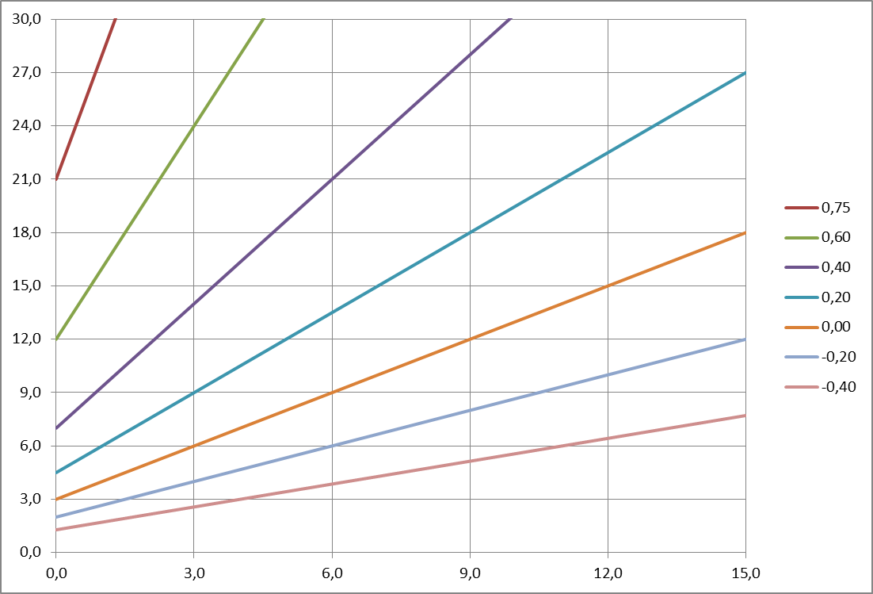

**Figure 3.2.1‑1: Example of ${TP}_{rank}$ values with *lbTpRankBias* = 3,0  
(X-axis: ${TP}_{source}$; Y-axis: ${TP}_{target}$)**

In this example, it might be appropriate to require ${TP}_{rank}>-0,2$ to select a UE. It would prevent UE with target TP less than ≈ 2 Mbps being selected, even if the source TP is virtually zero (other actions might be more appropriate for such UE).

On the other hand, a UE with relatively good source TP may be selected, even with a small degradation of the TP in the target cell. With a source TP of 12 Mbps, a target TP of 10 Mbps is sufficient to reach ${TP}_{rank}=-0,2$. The intention is to use a dynamic threshold for the ${TP}_{rank}$ criterion. If UE with higher rank are available, the dynamic threshold is increased and UE with ${TP}_{rank}=-0,2$ are not selected. However, it should be possible to configure a minimum ${TP}_{rank}$ threshold, where −0,2 could be a good default value.

### Dynamic ranking threshold

The dynamic ranking threshold requires a continuous monitoring of the ${TP}_{rank}$ values obtained when UE are evaluated. The objective is to maintain a dynamic threshold value that achieves a preconfigured discrimination rate, with the constraint that the threshold must not go below the required minimum threshold discussed in the previous section 3.2.1.

A method for this is described in [1]. However, it was develop for a different scenario and certain modifications are necessary.

The eNB maintains a ranking threshold, *lbTpRankThresh*, for each target cell (LB relation). When an LB relation is activated, the ranking threshold is initiated:

$${lbTpRankThresh}_{0}=lbTpRankThreshMin$$

When a UE is evaluated versus the target cell, the ${TP}_{rank}$ value is calculated and the UE is accepted and may be used for the load balancing action if:

$${TP}_{rank}≥lbTpRankThresh$$

Otherwise, it is rejected. The threshold is then updated:

$${lbTpRankThresh}_{n+1}={lbTpRankThresh}_{n}+lbTpRankFilterConst*d_{n} \\ {lbTpRankThresh}_{n+1}=max⁡({lbTpRankThresh}_{n+1}\text{ ; }lbTpRankThreshMin)$$

Where:

$$d_{n}=lbTpRankDiscrRateMin\text{ ; if UE is accepted} \\ d_{n}=lbTpRankDiscrRateMin-1 \text{; if UE is rejected }$$

The dynamic ranking threshold divides the evaluated UE in in a group of accepted UE with high ${TP}_{rank}$ values and a group of rejected UE with low ${TP}_{rank}$ values. The minimum share of rejected UE is controlled with the *lbTpRankDiscrRateMin* parameter.

The *lbTpRankThreshMin* parameter defines a minimum for the dynamic ranking threshold, in order to prevent that UE with too low ${TP}_{rank}$ values are accepted. When the *lbTpRankThreshMin* parameter restricts the dynamic ranking threshold, the share of rejected UE may increase and exceed the configured minimum share.

The *lbTpRankFilterConst* parameter controls how fast the dynamic ranking threshold adapts to fluctuations in the distribution of ${TP}_{rank}$ values.

## Conclusion

# Fallback alternative: RSRP based ranking

As a fallback alternative, if the TP "mapping function" turns out being infeasible, the feature could be implemented based on RSRP based ranking. This alternative is not fully investigated, as it is not seen as the wanted solution at this stage. Only some high level aspects are given.

Using an RSRP based ranking means that the TP "mapping function" is made obsolete. The TP value is either replaced with the RSRP value the UE reports, as is, or it be replaced by the RSRP margin relative a minimum RSRP for the particular cell.

The minimum RSRP could be the *qRxLevMin* parameter configured for the cell, or a separate minimum RSRP (new parameter) if the *qRxLevMin* parameter is not considered suitable. An advantage by comparing RSRP margins rather than the absolute RSRP level is that the method for TP ranking can be retained, allowing a prioritization of selecting UE in relatively poor conditions which can be improved by the load balancing action.

However, to be successful in this respect, it is essential that the minimum RSRP level is configured correctly in the cell, so that it reflects the minimum *useful* RSRP level in the cell, and that it is not just arbitrary selected. A self-tuning mechanism for this purpose would be helpful and could perhaps be designed along similar lines that the self-tuning mechanism for the TP assessment described in section 2.4.

If the reported RSRP values are used as is, the TP ranking in section 3.2 needs be modified. The ranking value should be a straight RSRP difference between the target and the source cell. The dynamic ranking threshold should be retained, but with some modification.

It would not be meaningful to apply a minimum rank threshold in this case, because the UE performance is not necessarily equal at equal RSRP in the two cells and the offset is unknown. On the other hand, the minimum share of rejected UE is controlled with the *lbTpRankDiscrRateMin* parameter should applicable in the same way. The filtering should be possible to do in the same way, although the values for the filter constant *lbTpRankFilterConst* would have to be scaled differently, as the RSRP difference would present much greater variation than the TP ranking value proposed in section 3.2.

# Parameterization and observability

## Configuration

### TP "mapping function"

Table 5.1.1‑1 below lists the parameters required for the configuration of the TP "mapping function".

**Table 5.1.1‑1: Configuration of the TP "mapping function"**

| **Parameter** | **Default and value range** | **Description** |
| --- | --- | --- |
| *lbCellPeakThroughput* | *dlChannelBandwidth* * 4 bps/Hz [1,0..200,0] | The CPT  Unit: Mbps (Values need be revised!) |
| *lbCellLoadFactorC1* | 6,330 [2,000..25,000] | The C1 parameter  Unit: Mbps (Values need be revised!) |
| *lbTpTuningRsrqMax* | −14,0 [−19,5..−3,0] | Maximum RSRQ for C2 assessment  Unit: dB |
| *lbTpTuningC2Offset* | −18,0 [−30,0.. −6,0] | If RSRQ ≤ *lbTpTuningRsrqMax* then C2 ~= RSRP – RSRQ + *bTpTuningC2Offset*  Unit: dB (Values need be revised!) |
| *lbTpTuningC2FilterConst* | 0,040 [0,005..0,200] | Filter constant for C2 filtering  (Values need be revised!) |
| *lbTpTuningC3Scaling* | 1,000 [0,500..2,500] | Factor for stretching the path loss curve  (Range need be revised!) |

### TP based ranking

Table 5.1.2‑1 below lists the parameters required for the configuration of the TP based ranking.

**Table 5.1.2‑1: Configuration of the TP based ranking**

| **Parameter** | **Default and value range** | **Description** |
| --- | --- | --- |
| *lbTpRankBias* | 3,0 [0,5..15,0] | Biasing the TP ranking to prevent offload into poor target TP  Unit: Mbps |
| *lbTpRankThreshMin* | −0,200 [−1,000..0,500] | Minimum TP rank threshold for selecting UE |
| *lbTpRankDiscrRateMin* | 0,350 [0,000..0,700] | Minimum discrimination rate at TP ranking |
| *lbTpRankFilterConst* | 0,048 [0,010..0,200] | Filter constant for TP ranking threshold  (Values need be revised!) |

## Observability

# Verification and risk

# References

1. [26/102 68-10/FCP 103 9669/12](http://erilink.ericsson.se/eridoc/erl/objectId/09004cff86a44cce?docno=26/10268-10/FCP1039669/12Uen&format=msw8): NDS: RSRP-Based UE Selection for Load Management
2. [84/0363-10/FCP 130 4300/14](http://erilink.ericsson.se/eridoc/erl/objectId/09004cff8856dc0a?docno=84/0363-10/FCP1304300/14Uen&action=current&format=msw12): TA report: UE Throughput Optimized IFLB

1. [3GPP TS 36.214](ftp://ftp.3gpp.org/Specs/archive/36_series/36.214/): E‑UTRA Physical Layer Measurements